PROJECT DESIGN PHASE-II
Technology Stack (Architecture & Stack)
Date | 02 October 2026
Team ID | SWTID-2026-9699
Project Name | LegalEase – AI-Powered Legal Document Generator
Maximum Marks | 4 Marks

Technical Architecture
LegalEase is organized as a Streamlit user interface, a FastAPI backend, a Gemini-based generation service, and a document-formatting service. The architecture below shows the main components and the flow between them.
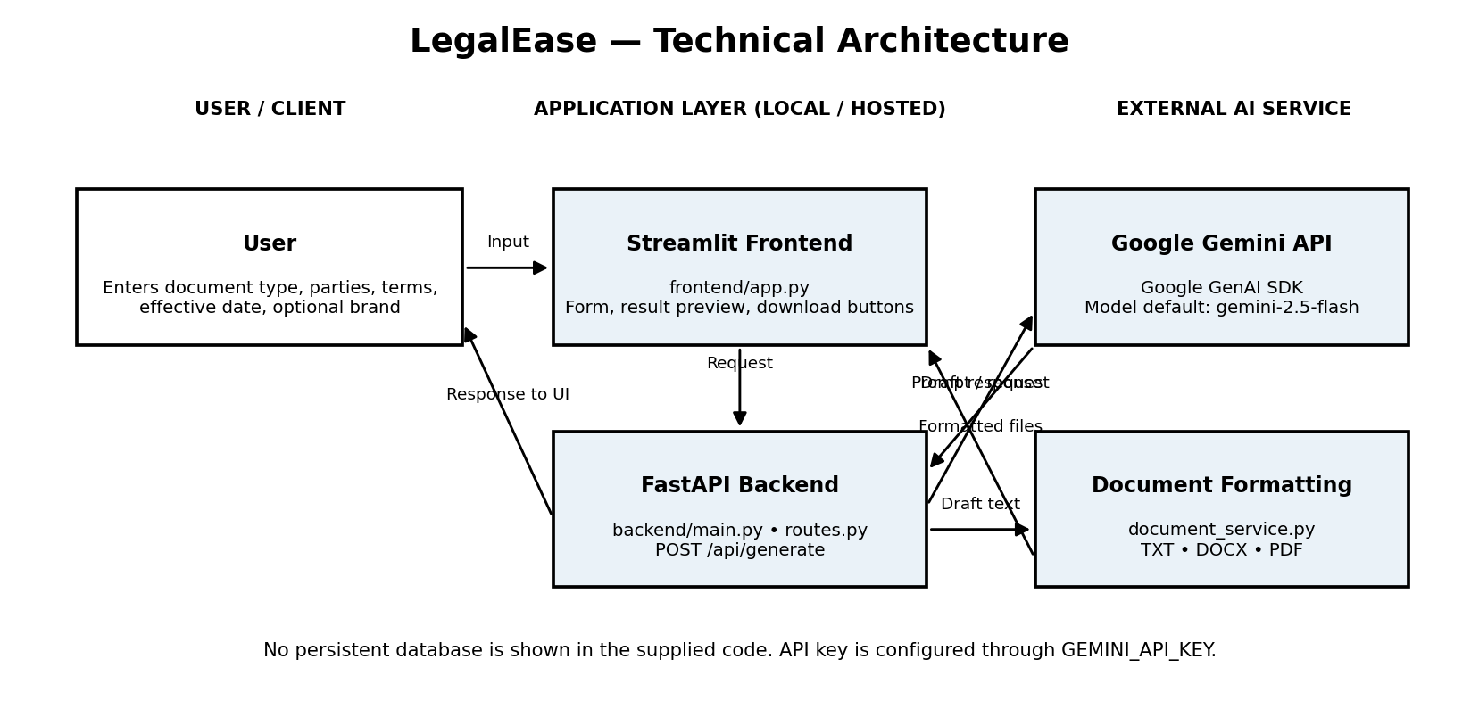
Deployment boundary: the application can be run locally or hosted, depending on the configured environment. The supplied project material does not identify a confirmed production hosting configuration. Gemini is an external API. No persistent database is shown in the supplied implementation.

Table-1: Components & Technologies
S.No | Component | Description | Technology
1 | User Interface | Web interface for selecting a document type, entering details, viewing the generated draft, and downloading files. | Python, Streamlit (frontend/app.py)
2 | Application Logic-1 | Receives and validates the document-generation request. | Python, FastAPI, Pydantic (backend/main.py, schemas.py, routes.py)
3 | Application Logic-2 | Builds the prompt and requests a legal-document first draft. | Google GenAI SDK; Gemini model (default: gemini-2.5-flash)
4 | Application Logic-3 | Normalizes generated content and creates downloadable document formats. | Python; python-docx; ReportLab (document_service.py)
5 | Database | The supplied implementation does not show a database for persistent application records. | Not specified / not present in supplied code
6 | Cloud Database | No cloud database service is shown in the supplied project materials. | Not specified
7 | File Storage | Generated TXT, DOCX, and PDF files are prepared for user download. Persistent server-side storage is not established by the supplied code. | In-memory generation and download response; local file system may be used by runtime
8 | External API-1 | Generates the requested first-draft legal document from the prompt and user-provided details. | Google Gemini API via Google GenAI SDK
9 | External API-2 | No second external API is identified in the supplied project code. | Not applicable
10 | Machine Learning Model | Language generation for drafting document text. | Gemini; default model gemini-2.5-flash; configurable using GEMINI_MODEL
11 | Infrastructure (Server / Cloud) | Streamlit frontend and FastAPI backend run as application services. Environment variables configure the Gemini key/model. | Local or hosted runtime; Docker support is included; production host not confirmed

Table-2: Application Characteristics
S.No | Characteristics | Description | Technology
1 | Open-Source Frameworks | The application uses open-source Python frameworks and document-generation libraries. | Streamlit, FastAPI, Pydantic, python-docx, ReportLab
2 | Security Implementations | The Gemini API key is read from GEMINI_API_KEY rather than hard-coded in the generator. The supplied code does not establish authentication, role-based access, or encryption at rest. | Environment variable configuration; additional access controls should be verified before deployment
3 | Scalable Architecture | The frontend, API routes, generation service, and document formatting service are separated into components. The supplied material does not demonstrate independently scaled microservices. | Streamlit + FastAPI + service modules
4 | Availability | The API includes a /health endpoint. High availability, load balancing, and distributed deployment are not evidenced in the supplied files. | FastAPI health endpoint; hosting configuration dependent
5 | Performance | Generation calls an external Gemini model. Prompt generation uses temperature 0.2; no measured requests-per-second, cache, or CDN configuration is supplied. | Gemini API; asynchronous throughput / caching not claimed

Configuration & Notes
Required configuration: GEMINI_API_KEY. Optional configuration: GEMINI_MODEL, which overrides the default model. Generated content is a first draft and should be reviewed by a qualified legal professional. The technology and deployment details above are limited to what is described in the supplied LegalEase project documentation and code.

